API Documentation

Version: 1.0

Base URL: <http://localhost:8082/>

Auth Controller

## 1. Authorize

Method: POST

Endpoint: /api/auth/authorize

**Parameters**

* authorizeRequest (object, required): The request object for authorization.

**Example Value**

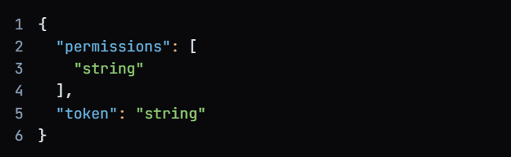

**Response Codes**

* 200: OK

**Example Value:**



* 201: Created
* 401: Unauthorized
* 403: Forbidden
* 404: Not Found

## 2. Get ID By Token

Method: POST

Endpoint: /api/auth/getIdByToken

**Parameters**

* token (string, required): The token to retrieve the ID.

**Example Value:**

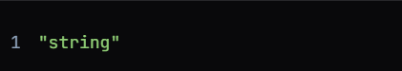

**Response Codes**

* 200: OK

**Example Value:**



* 201: Created
* 401: Unauthorized
* 403: Forbidden
* 404: Not Found

## 3. Login

Method: POST

Endpoint: /api/auth/login

**Parameters**

* tokenRequest (object, required): The request object for login.

**Example Value:**

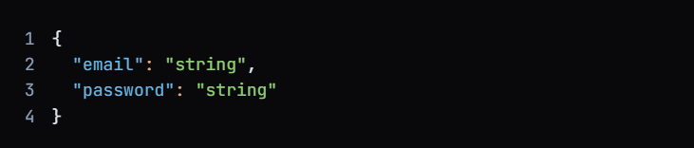

**Response Codes**

* 200: OK

**Example Value:**

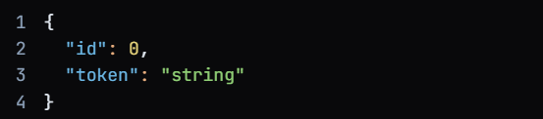

* 201: Created
* 401: Unauthorized
* 403: Forbidden
* 404: Not Found

## 4. Register

Method: POST

Endpoint: /api/auth/register

**Parameters**

* data (object, required): The registration data.

**Example Value:**

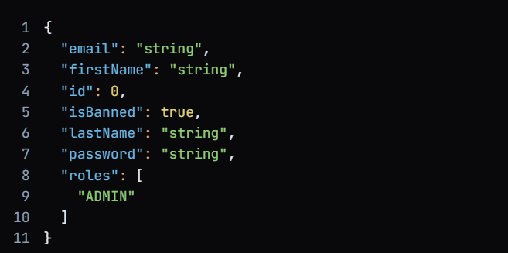

**Response Codes**

* 200: OK

**Example Value:**

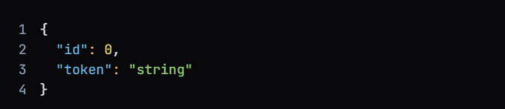

* 201: Created
* 401: Unauthorized
* 403: Forbidden
* 404: Not Found

## AuthorizeRequest

Type: Object

**Required Properties:**

* permissions
* token

**Properties:**

* permissions (array of strings)

Description: List of permissions associated with the request.

* token (string)

Description: Authentication token.

## ModelAndView

Type: Object

Required Properties:

* empty
* model
* modelMap
* reference
* status
* view
* viewName

**Properties:**

* empty (boolean)

Description: Indicates if the model is empty.

* model (object)

Description: The model data.

* modelMap (object)

Description: A map of model attributes.

* reference (boolean)

Description: Indicates if the model is a reference.

* status (string)

Description: The status of the response.

* view (View)

Description: The view associated with the model.

* viewName (string)

Description: The name of the view.

**Enum Values for Status:**

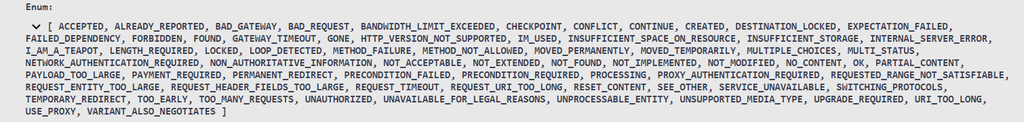

**Example Value:**

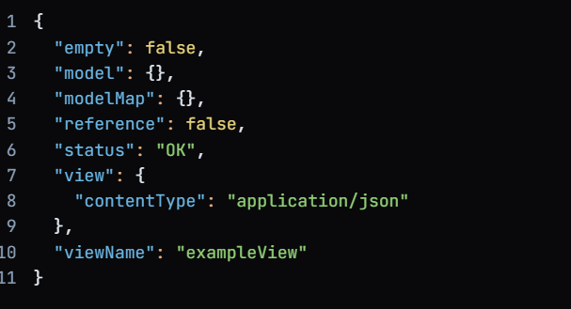

**TokenRequest**{

|  |  |
| --- | --- |
| email | string |
| password | string |

}

**TokenResponse**{

|  |  |
| --- | --- |
| id | integer($int64) |
| token | string |

}

**UserModel**{

|  |  |
| --- | --- |
| email | string |
| firstName | string |
| id | integer($int64) |
| isBanned | boolean |
| lastName | string |
| password | string |
| roles | [...] |

}

**View**{

|  |  |
| --- | --- |
| contentType | string |

}

# Models